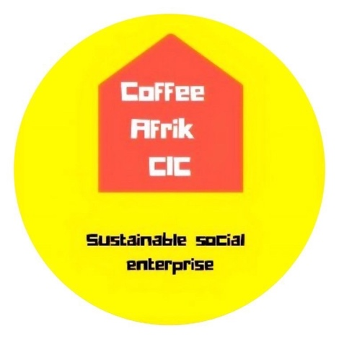
TNL Impact Report: Somali Mental Health Project

““I feel more optimistic about my future. I am coping better than before. I have been more motivated to take charge of my life from the knowledge that was provided on this program​.”.
Peer-to-Peer Participant
Summary of TNL Impact
• A co-produced peer-to-peer support group, led by women, for women, by women.
• Organised group sessions and 1 to 1 meeting, with our clients led by a Somali therapist, covering topics such as autism, breast cancer awareness, and predominantly mental health.
• Incorporated our referral pathway model into the project, which connected our clients to over 45 third sector organisations across the London Borough of Hackney.
• Improved digital inclusion by purchasing tablets for clients to engage with our therapist over zoom.
• Clients on the project have recorded an 89% improvement in mood, morale, and resilience.
• We have dealt with a 300% increase in referrals with over 85% of referrals now closed, with the remaining soon to be.
• The large majority of our referrals were medical issues covering both physical and mental health led at 55%, with 25% made up of financial difficulties, and finally, 20% related to housing need

Our aim:
The vision and aim behind our project has been led by a passion to coordinate a peer-to-peer support program for older Somali women who are currently facing a mental health epidemic. As the only Somali focused organisation in Hackney, we found ourselves in a very unique position to offer such a service.
The approval of this grant has allowed us to reset, pause and focus on our client's healing. In addition to facilitating the breakdown of mental barriers, by empowering our clients to lead their own peer to peer support whilst co-producing our referral pathway model.
A large contributor to the success of this project was the employment of a culturally sensitive women-led Somali therapist, who brought her unique insight and experience, leaving our participants with a renewed sense of self-confidence and purpose. Moreover, the incorporation of our culturally sensitive referral pathway model has eased the process in which clients are referred to healthcare professionals and providers.
Understanding the importance of culturally competence in providing care to clients from diverse backgrounds cannot be overlooked, with the success of this project testament to this. As such we shall continually promote the need for culturally sensitive services embedded within healthcare services, in the hopes of reducing health disparities.

Importance of our Project
- Many of our clients have existing underdiagnosed mental health conditions.
- Largely a result of their experience and difficulties, pre, post and during the migratory process have all combined to influence mental illness rates amongst the Somali community.
- Our work on the ground has helped heal clients due to our understanding of the plights faced by the community when it comes to accessing healthcare services.
- The work we do ensures those suffering from mental illness can access culturally acceptable assistance and thus receive safe treatment through
our referral pathway
model.
Source: Trauma, poverty and mental health among Somali and Rwandese refugees living in an African refugee settlement – an epidemiological study. Confl Heal. 2009;

Somali Communities in London have additional barriers to accessing care including mistrust of the system and fear, cultural barriers, and anxiety over immigration status and access to housing.

Impact of Covid19
The severity of Covid19 coupled with the announcement of UK wide lockdowns brought about a unique obstacle for our project. However, where others saw challenges, we sought solutions. Pivoting away from a face-to-face group setting; this allowed us to introduce the UK’s first-ever digital peer to peer Somali women’s group.
The aim for us was to highlight issues that are considered taboo in the community and facilitating the breakdown of barriers by creating safe spaces for women to discuss issues such as anxiety, depression,​ and PTSD.
We began with commissioning the purchase of tablets for our clients, preprogramed with zoom, in addition to setting up an email account for users. We organised weekly group sessions, along with conducting one to one meetings granting clients the opportunity to delve into more private issues with our lead therapist. The impact on our client's continued mental recovery cannot be underestimated, without so, many of our clients would have fallen further into crisis.
‘This project has impacted my life in a positive way. I am able to communicate with others about various topics and know about their wellbeing during Covid. It has helped me work through my mental problems which were greatly impacted due to lockdown restrictions”.
Peer-Peer Participant
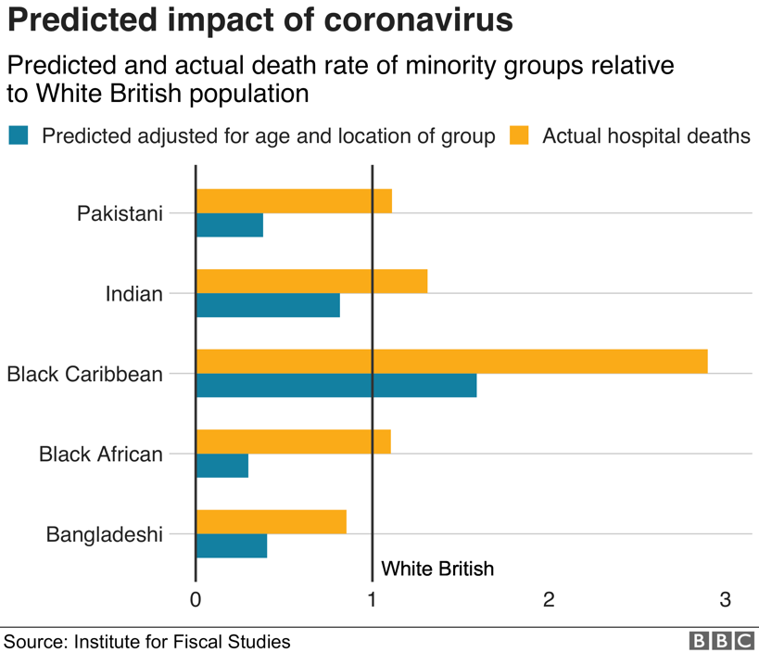
Covid19 effect on BAMER lives:
- The hardest hit are those individuals categorised as BAMER whose both psychical and mental health have been adversely affected.
- Additionally, with the current UK-wide lockdown measures, this has greatly reduced access to mental care (face-to face visits and talking therapies) for those who most require it.
- As an organisation, we have made it our top priority to fill this void but resolving this issue through our use of digital peer to peer support.

A consequence of our organisation not intervening and aiding clients would have more than likely contributed to an increase in severity of mental illness, increase in self-harm and suicide rates, and widening of existing health inequalities among the Somali community.

Our work on this project has not come at a more important juncture for the Somali community here in Hackney. Sadly, over 25 participants have lost loved ones within the past year, to avoid this continued impact, serious work was needed to address the fear and anxiety evidently gripping the community.
As a result, we made it an utmost priority to use our platform to transmit important Public Health information, especially with the lack of sufficient culturally appropriated material. We took it upon ourselves to bridge this gap, in turn, providing translated documents, which assisted in quelling the issue of misinformation and scepticism around vaccinations.

Before Covid Awareness Workshop After Covid Awareness Workshop

Due to our continued efforts, we have seen improvements in the wellbeing of our clients, as they become more educated around this matter, with our latest survey showing 88% of clients now willing to take the vaccine as opposed to a mere 21% at the beginning of the pandemic. As a result of our impact, we are currently working with the Mayor of London to organise a UK wide web event that will discuss how we can reduce the impact of Covid on the Somali community here in the UK.

Peer to Peer Support group/Referral Pathway Model
Great emphasis was placed on creating an environment focused on peer-to-peer support where clients help support one another with their lived experience of mental illness and learning disability. This level of support came in many forms such as social, emotional, and practical support but most importantly this support was mutually offered and reciprocal, allowing peers to benefit whether they are giving or receiving it.
The key focus for us specifically with mental health was to build on their participant's shared personal experience and empathy, focusing on their individual strengths as opposed to their weakness, with greater importance placed on the individual’s wellbeing and recovery.

Referral Pathway Model:
- Our determination to develop a project which would revolve around mental health, Covid recovery, intersectionality and how our clients have been impacted was key.
- As a result, incorporating our referral pathway model was of great significance to us, since this has allowed our women to connect through to other third sector organisation, assisting in the provision of recovery support to be established, with the ultimate aim
for our clients to return to an independent and fulfilling life.

The importance behind integrating our referral pathway model into this project was largely due to the absence of culturally sensitive support provided by both local and statutory services, particularly for POC. To combat this, we have connected our clients to other complementary BAMER organisation in addition to linking them to a network with over 45 other organisations. As a consequence, we were able to deal with and resolve many of our client’s woes and concerns

Demand for Non-medical Services:
- The continued UK-wide lockdown has contributed further to the decrease in our client’ psychological
health, largely due to employment and financial concerns.
- As a result, we witnessed a surge in demand for our other jointly run services, particularly with regards to our food-coop which saw an increase of 156%, with this number continually rising on a weekly basis.
- Although, food isn’t the only sole concern of our clients with many requiring housing and financial assistance too.
- During this project we have observed a 400% increase in referrals to the likes of Nawaal Fund Charity who specialises in offering financial assistance.
- As a result, many clients were able to pay off large debts, which has greatly improved their mental health since they no longer have to endure the impeding anxious wait for bailiffs or eviction notices.
43% of BAME individuals are concerned about meeting bills in the next three months.

Source:FCA
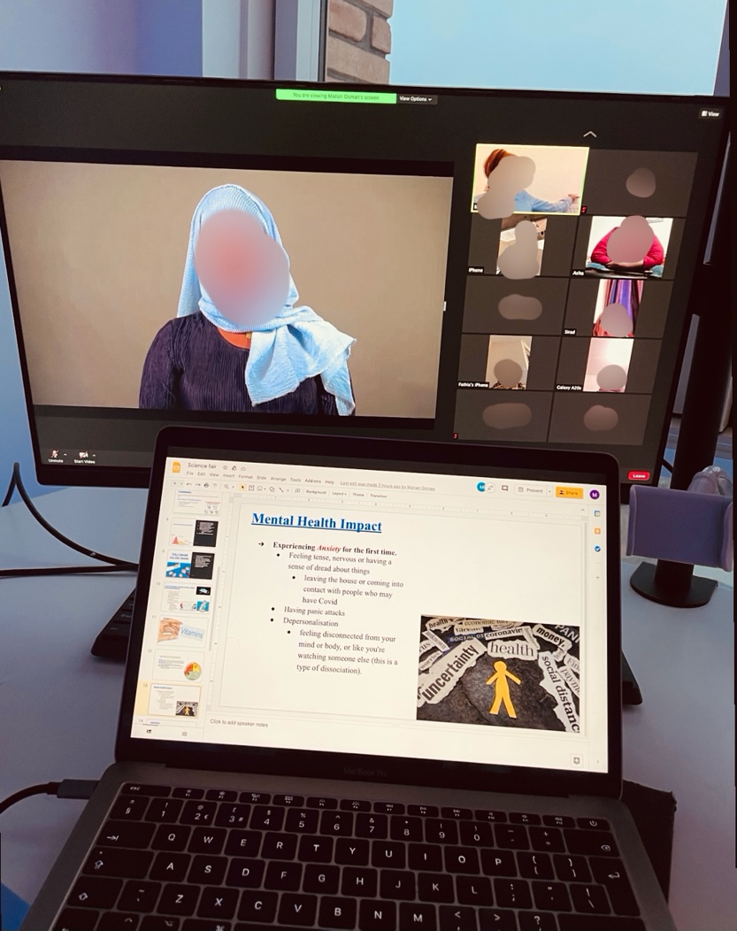

“I recently lost my job due to the pandemic which trigged my depression as I struggled with meeting ends meet as a single mother. So, when a friend introduced me to Coffee Afriks food coop I was extremely relieved. The coop has meant that I no longer worry about my next meal. This has greatly improved my own mental health”.
Peer-to-Peer Participant

Peer to Peer Support
At our core, we believe in empowerment, hence why from the very beginning of this project we have encouraged our women to govern and manage this project. The reason behind this was to create an environment where women were comfortable speaking on matters close to their hearts. Clients would take turns weekly leading on a particular topic providing their insight on the subject through their lived experience. It was evidently clear early on that we created something special and that this project was going to be a success.
As an illustration we provided clients the opportunity to present and speak on topics to the group through presentations, with on hand expert support provided by our therapist. Some of the topics covered during these interactions varied from breast cancer awareness to autism within the Somali community. It was beautiful to witness women leading discussions on-topic considered taboo within the community. The women played a key role in contributing towards demolishing the societal barriers which currently exist around such subject areas.
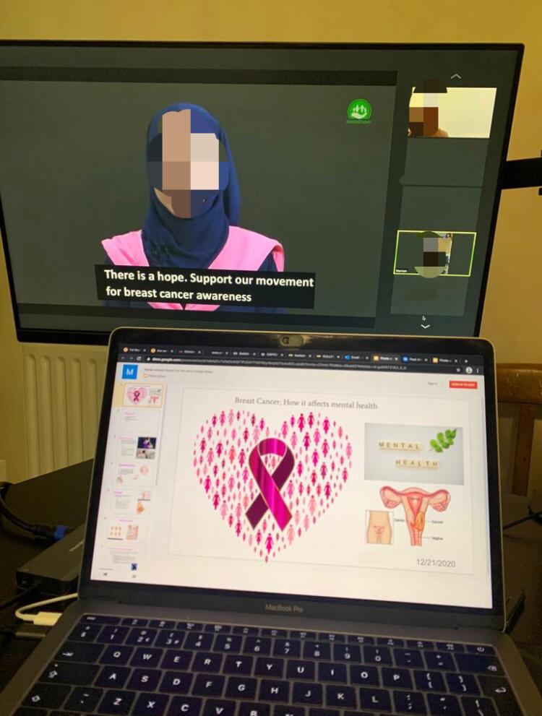

“I enjoy the diversity of topics we discuss, and how they relate to my mental health. I have learned from many topics, in particular the topic on breast cancer awareness. At the end of last year, I had a breast cancer scare which impacted my mental health. Attending these group sessions, I have learned not to fear going for assessments, and to normalize going for health-check-ups”.
Peer-to-peer participant

Before Breast Cancer Awareness Workshop After Breast Cancer Awareness Workshop

A resulting factor from the topic on Breast cancer awareness was the tremendous rise in clients asking to be referred for checks, up by 300%. The hesitancy in taking up initial examinations was evident during the group session, according to our therapist who stated – ‘The apprehension and anxiety arose due to carcinophobia, which essentially means the fear of getting cancer, thus scaring many of clients out of assessment, however, once I clarified their fears, many sought out assessment through our referral pathway model’. Lead therapist.
In one instance we had a client who led on the topic of autism in the Somali community, and the difficulties which came with raising a non-verbal child. Speaking on her experience having faced a great deal of mental anguish having suffered from loneliness, ridicule, and abandonment by her community. She had extreme courage to present this topic, educating other participants on how to deal with ​and take care of your wellbeing. The feedback was extremely pleasant with many clients admitting that they had an ill-informed view on such matters.

We have witnessed an 89% improvement in mood, moral and resilience of our clients.

“I am extremely thankful for Marian (lead therapist), her cultural understanding has helped me immensely to tackle the ghosts I have kept buried. Now, I help support her on topics, leading discussion I once thought were taboo in the community. Overall I am excited to see what the future holds, now that I have this weight lifted”
Peer-to-Peer Participant

Source: Internal Survey 2021
Future Plan:
On the back of the success of the UK’s first-ever Somali digital peer to peer women’s support group, valuable lessons were learned. Countless medical studies show support towards the concept of peer to peer in addressing the stigma around mental health and resolving the ongoing mental health epidemic currently gripping the Somali community. However, more needs to be done and as a result we are advocating for more support towards similar projects. Although our focus is predominantly East London this isn’t an isolated issue, with over 90,000 Somalis currently living in London, many more communities across London and afar require similar or a greater level of support.
Nonetheless, with the backing from TNL, I truly believe we are in the best position to reach even those that remain on the fringiest of society. As our unique digital concept has meant that we are no longer restricted by the four walls of a room. Interested clients can simply seek culturally appropriate services from the comfort of their home using digital means.
Additionally, a key component for our success, is largely due to the significant impact played by our Somali therapist whose work on this project has changed the lives of our clients for the better. Her ability to build a real bond and connection with each client, helped her to dive deeper than any other medical worker before, getting to the root cause of our client’s troubles. In addition to providing our women a platform to lead on topics using their shared experiences, with a focus on recovery, ultimately helping to facilitate our clients to go on and lead independent and fulfilling lives.
The project was made complete by our referral pathway model which sought to address our clients’ needs both medical and non-medical. The ease in which they were referred greatly assisted our work in changing their lives for the better. In short, we hope TNL sees the huge impact this project has had on our clients and continue to support the implementation of this framework across multiple boroughs and eventually UK wide.

